**Assignment -4**

|  |  |
| --- | --- |
| Assignment Date | 23 October 2022 |
| Student Name | S.Arun Kumar |
| Student Roll Number | 511319104008 |
| Maximum Marks | 2 Marks |

**Question-1:**

Write code and connection in wokwi for ultrasonic sensor . whenever the distance is less tha 100cms send "alert" to ibm cloud and display in device recent events

//Firstly the connections of ultrasonic Sensor.Connect +5v and GND normally and trigger pin to 12 & echo pin to 13.

#define trigPin 12

#define echoPin 13

int Buzzer = 8; // Connect buzzer pin to 8

int ledPin= 6; //Connect LEd pin to 6

int duration, distance; //to measure the distance and time taken

void setup() {

Serial.begin (9600);

//Define the output and input objects(devices)

pinMode(trigPin, OUTPUT);

pinMode(echoPin, INPUT);

pinMode(Buzzer, OUTPUT);

pinMode(ledPin, OUTPUT);

}

void loop() {

digitalWrite(trigPin, HIGH);

delayMicroseconds(10);

digitalWrite(trigPin, LOW);

duration = pulseIn(echoPin, HIGH);

distance = (duration/2) / 29.1;

//when distance is less than or equal to 100,the buzzer and LED are off

if (distance <= 100)

{

Serial.println("no object detected");

digitalWrite(Buzzer,LOW);

digitalWrite(ledPin,LOW);

}

else {

Serial.println("object detected \n");

Serial.print("distance= ");

Serial.print(distance); //prints the distance if it is between the range less than 100

tone(Buzzer,400); // play tone of 400Hz for 500 ms

digitalWrite(ledPin,HIGH);

}

}

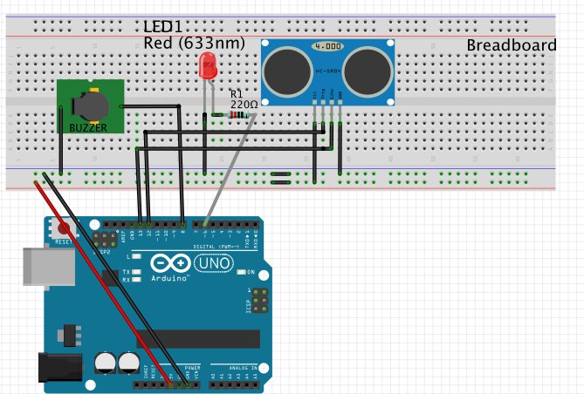

wokwi link:https://wokwi.com/projects/346311962855998034